**Project Documentation**

**Online Library System – Microservices with Docker & Independent Databases**

#### **1.Setup Each Microservice:**

1️.Catalog Service

* **Language:** Python
* **Framework:** Flask
* **Database:** PostgreSQL
* **Responsibility:** Manage books
* **Base API:** /catalog

2️.User Service

* **Language:** Python
* **Framework:** Flask
* **Database:** MySQL
* **Responsibility:** Manage users
* **Base API:** /users

3️. Order Service

* **Language:** Node.js
* **Framework:** Express.js
* **Database:** MySQL
* **Responsibility:** Manage orders
* **Base API:** /orders

**2. Database Configuration**

The Online Library System is designed with three fully independent database instances, each running within its own dedicated Docker container to ensure strict data isolation and adherence to microservices architecture principles. The **catalog-db** container, based on PostgreSQL, is responsible for storing all book-related data required by the Catalog Service, including book records and associated attributes. The **user-db** container, implemented using MySQL, manages user profile information for the User Service, while the **order-db** container, also using MySQL, stores order-related data for the Order Service. Each database is configured with a unique database name, database user, and password, all of which are defined as environment variables within the docker-compose.yml file. This configuration prevents credential sharing between services and ensures that each microservice can access only its own database. To guarantee data persistence across container restarts or rebuilds, a dedicated Docker volume is assigned to each database container, namely catalog_data, user_data, and order_data. These volumes store database files outside the container filesystem, ensuring that all data remains intact even when containers are stopped or removed. Additionally, all database containers and their corresponding microservices are connected to a common Docker bridge network named **library-net**, which enables secure and controlled communication between services while maintaining network isolation from the host system and external environments. This overall database configuration provides reliability, scalability, and full compliance with the requirements of the assignment.

**3. Docker Configuration**

Each microservice was containerized using a dedicated Dockerfile that defines the runtime environment and required dependencies. For the Catalog and User Services, which are implemented using Python and Flask, Dockerfiles were created to install Python, Flask, database drivers, and all necessary packages listed in their respective requirements.txt files. This approach ensures that each service runs in a consistent and reproducible environment.

The Order Service, implemented using Node.js and Express.js, includes its own Dockerfile to install Node.js dependencies defined in the package.json file. All services are built and executed inside Docker containers, eliminating dependency conflicts and ensuring portability. Docker Compose is used to manage and connect the services with their databases. Since Docker Compose handles container orchestration automatically, the use of Composer or manual container deployment was not required. A common Docker network named **library-net** was defined to enable controlled communication between services and their corresponding databases.

**4. Database Connectivity**

In this project, database connectivity is implemented following the principles of a microservices architecture, where each service operates independently and communicates exclusively with its own dedicated database instance. This design ensures full isolation between services, improved scalability, and easier maintenance, while strictly complying with the assignment requirement that each microservice must use a separate database and connect to it using environment variables.

Each microservice (Catalog Service, User Service, and Order Service) retrieves its database connection parameters through environment variables defined in the docker-compose.yml file. These environment variables include DB_HOST, DB_NAME, DB_USER, and DB_PASS, which respectively specify the database hostname, database name, database user, and database password. By using environment variables instead of hard-coded credentials, the configuration remains secure, flexible, and easily adjustable for different deployment environments without requiring changes to the application source code.

The Catalog Service is implemented using Python and Flask and connects to a PostgreSQL database running inside a dedicated Docker container named catalog-db. The database connection is established using SQLAlchemy together with the PostgreSQL driver (psycopg2), and the connection string is dynamically constructed at runtime using the environment variables provided by Docker Compose. This approach ensures that the Catalog Service can reliably access its database within the Docker network while remaining completely independent from the databases used by other services.

Similarly, the User Service is implemented using Python and Flask and connects to its own MySQL database instance running in a separate Docker container named user-db. The service uses SQLAlchemy with the PyMySQL driver to establish the database connection. All connection parameters are read from the environment variables injected by Docker Compose, guaranteeing that the User Service communicates only with its own database and does not share any storage or credentials with other microservices in the system.

The Order Service is implemented using Node.js with the Express.js framework and connects to a dedicated MySQL database container named order-db. The database connection is created using the mysql2 library, which reads the required database credentials (DB_HOST, DB_NAME, DB_USER, DB_PASS) from environment variables at runtime. A connection pool is used to efficiently manage database connections, ensuring stable and performant communication between the Order Service and its database.

All database containers and microservices are connected to a common Docker bridge network named library-net. This network enables reliable container-to-container communication using Docker service names as hostnames, such as catalog-db, user-db, and order-db. At the same time, the use of a shared network does not compromise isolation, as each microservice is configured to connect only to its own database instance through its specific environment variables.

To verify correct database connectivity, each microservice provides a dedicated database health-check endpoint (for example, /catalog/db-check, /users/db-check, and /orders/db-check). These endpoints execute a simple test query (SELECT 1) against the corresponding database to confirm that the connection has been successfully established. Successful responses from these endpoints serve as clear evidence that each service can independently access its database, satisfying the functional and architectural requirements of the assignment.

Overall, this database connectivity implementation fully meets the assignment requirements by ensuring independent databases for each microservice, secure and configurable database credentials through environment variables, and reliable communication within a Docker-orchestrated microservices environment. This approach reflects best practices in modern microservices design and demonstrates a clear separation of concerns between services and their underlying data storage.

**5. Docker Compose Setup**

A docker-compose.yml file was created to orchestrate the microservices and their independent database containers. The compose configuration defines three database containers (catalog-db, user-db, order-db) and three application containers (catalog-service, user-service, order-service). All containers are attached to a shared Docker network named library-net, allowing container-to-container communication using service names as hostnames. Persistent storage is ensured by dedicated Docker volumes (catalog_data, user_data, order_data) mapped to the appropriate database data directories, ensuring that data remains available across container restarts. Each microservice receives its database configuration via environment variables (DB_HOST, DB_NAME, DB_USER, DB_PASS), ensuring that each service connects only to its own database instance.

**6. Basic CRUD Functionality**

To fulfill the requirement for basic CRUD (Create, Read, Update, Delete) functionality, each microservice in the Online Library System was implemented with a set of RESTful API endpoints that allow independent data management. Each service operates autonomously and interacts only with its dedicated database, following the principles of microservices architecture.

The **Catalog Service**, developed using Python and Flask and connected to a PostgreSQL database, manages information related to books. It exposes CRUD endpoints under the /catalog base path. The mandatory READ functionality is implemented through an endpoint that retrieves all book records from the database and returns them in JSON format. Additional endpoints support creating new books, retrieving individual book records, updating existing entries, and deleting books.

The **User Service**, implemented using Python and Flask with a MySQL database, is responsible for managing user profiles. It provides CRUD operations under the /users base path. The required READ functionality retrieves all user records from the database, confirming successful database connectivity and data retrieval. The service also includes endpoints for creating, updating, and deleting user profiles.

The **Order Service**, developed using Node.js and Express.js and connected to a separate MySQL database, manages book orders. CRUD endpoints are exposed under the /orders base path. The mandatory READ operation retrieves all order records, while additional endpoints enable the creation, modification, and deletion of orders.

All READ endpoints were tested using HTTP requests and successfully returned valid JSON responses, including empty arrays when no data was present. This behavior confirms correct implementation of the required functionality. Overall, the CRUD implementation across all microservices fully satisfies the assignment requirements, with the mandatory READ operations correctly implemented and tested, and full CRUD support provided for completeness and extensibility.

**7. Testing**

After completing the implementation and configuration of all microservices and their corresponding databases, each service was tested to verify correct functionality and independent database communication. The testing phase focused on validating that every microservice could successfully process HTTP requests, perform CRUD operations, and interact exclusively with its own database instance while running inside Docker containers.

Testing was conducted using **Postman**, which was used to send HTTP requests to the exposed RESTful APIs of each microservice. For the **Catalog Service**, HTTP requests were sent to endpoints under the /catalog base path to verify that book data could be retrieved from the PostgreSQL database. The mandatory READ operation (GET /catalog/books) was tested and returned a valid JSON response, confirming that the service was correctly connected to its database and capable of retrieving stored data. Additional CRUD operations, including CREATE, UPDATE, and DELETE, were also tested to ensure full functionality.

The **User Service** was tested by sending HTTP requests to endpoints under the /users base path. The mandatory READ endpoint (GET /users) was executed successfully and returned a valid JSON array, demonstrating proper communication between the User Service and its MySQL database. Further tests included creating new user profiles, updating existing records, retrieving individual users, and deleting users, confirming that the service supports full CRUD functionality and operates independently from the other services.

Similarly, the **Order Service** was tested through endpoints under the /orders base path using Postman. The mandatory READ operation (GET /orders) returned a valid JSON response, verifying that the Node.js and Express-based service could connect to its MySQL database and retrieve order data correctly. Additional CRUD operations, such as creating new orders, updating order details, retrieving individual orders, and deleting orders, were also tested successfully.

All tests confirmed that each microservice operates independently, communicates only with its own database, and responds correctly to HTTP requests. The successful execution of CRUD operations across all services demonstrates that the microservices architecture is correctly implemented and fully functional. Screenshots of the Postman requests and responses were collected as testing evidence to support the correctness of the implementation.

**8.Brief CRUD Description per Service**

## Catalog Service — Books (Flask + PostgreSQL)

* CRUD operations for books

Implementation:

* **Create book** → POST /catalog/books
* **Read all books (MANDATORY)** → GET /catalog/books
* **Read single book** → GET /catalog/books/{id}
* **Update book** → PUT /catalog/books/{id}
* **Delete book** → DELETE /catalog/books/{id}

## User Service — Users (Flask + MySQL)

* CRUD operations for user profiles

Implementation:

* **Create user** → POST /users
* **Read all users (MANDATORY)** → GET /users
* **Read single user** → GET /users/{id}
* **Update user** → PUT /users/{id}
* **Delete user** → DELETE /users/{id}

## Order Service — Orders (Node.js + Express + MySQL)

* CRUD operations for orders

Implementation:

* **Create order** → POST /orders
* **Read all orders (MANDATORY)** → GET /orders
* **Read single order** → GET /orders/{id}
* **Update order** → PUT /orders/{id}
* **Delete order** → DELETE /orders/{id}

## ****Environment Variables and Deployment Instructions****

**Environment Variable Configuration**

Each microservice in the Online Library System is configured to connect to its respective database using environment variables. This approach follows best practices by separating configuration from application logic and avoiding hard-coded database credentials. Environment variables are defined for each service directly within the docker-compose.yml file and are injected into the containers at runtime.

The environment variables used by all services include DB_HOST, DB_NAME, DB_USER, and DB_PASS. The DB_HOST variable specifies the hostname of the database container, which corresponds to the service name defined in Docker Compose (for example, catalog-db, user-db, or order-db). Docker’s internal networking automatically resolves these hostnames, allowing each microservice to communicate with its designated database. The variables DB_NAME, DB_USER, and DB_PASS define the database name, user, and password that are unique to each service, ensuring database isolation and security.

By defining these variables in Docker Compose, the same application code can be deployed in different environments without modification, simply by changing the configuration values.

**Running the Application Using Docker Compose**

Docker Compose is used to manage and orchestrate all microservices, databases, networks, and volumes in the system. It simplifies deployment by allowing the entire application stack to be started with a single command. The docker-compose.yml file defines all services, their dependencies, environment variables, volumes for persistent storage, and the shared Docker network.

To build and start all containers, the following command is executed from the root project directory:

docker-compose up --build -d

This command performs the following actions:

* Builds Docker images for each microservice using their respective Dockerfiles.
* Starts all service and database containers in detached mode.
* Automatically creates the shared Docker network (library-net) if it does not already exist.
* Attaches the appropriate volumes to database containers to ensure persistent data storage.

To stop and remove all running containers while preserving stored data, the following command is used:

docker-compose down

This approach ensures consistent, repeatable deployment and is recommended for managing multi-container applications.

**Testing Evidence**

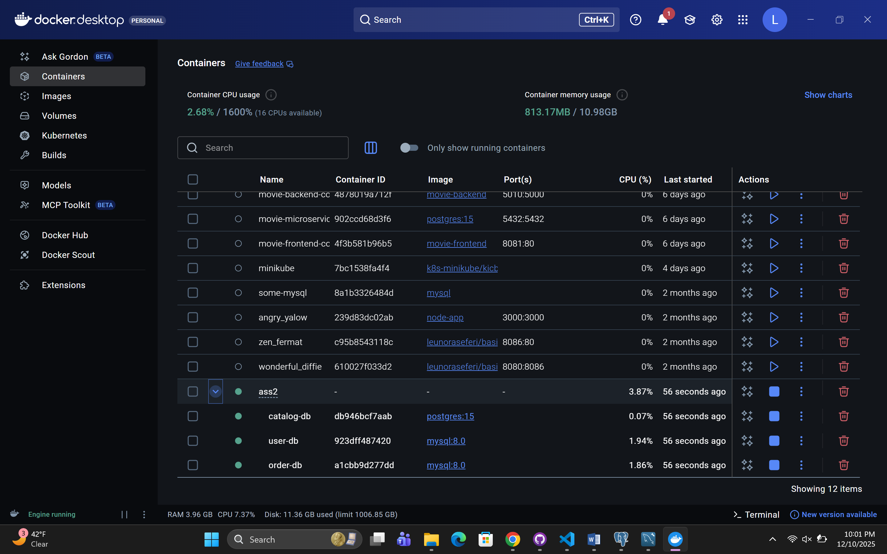

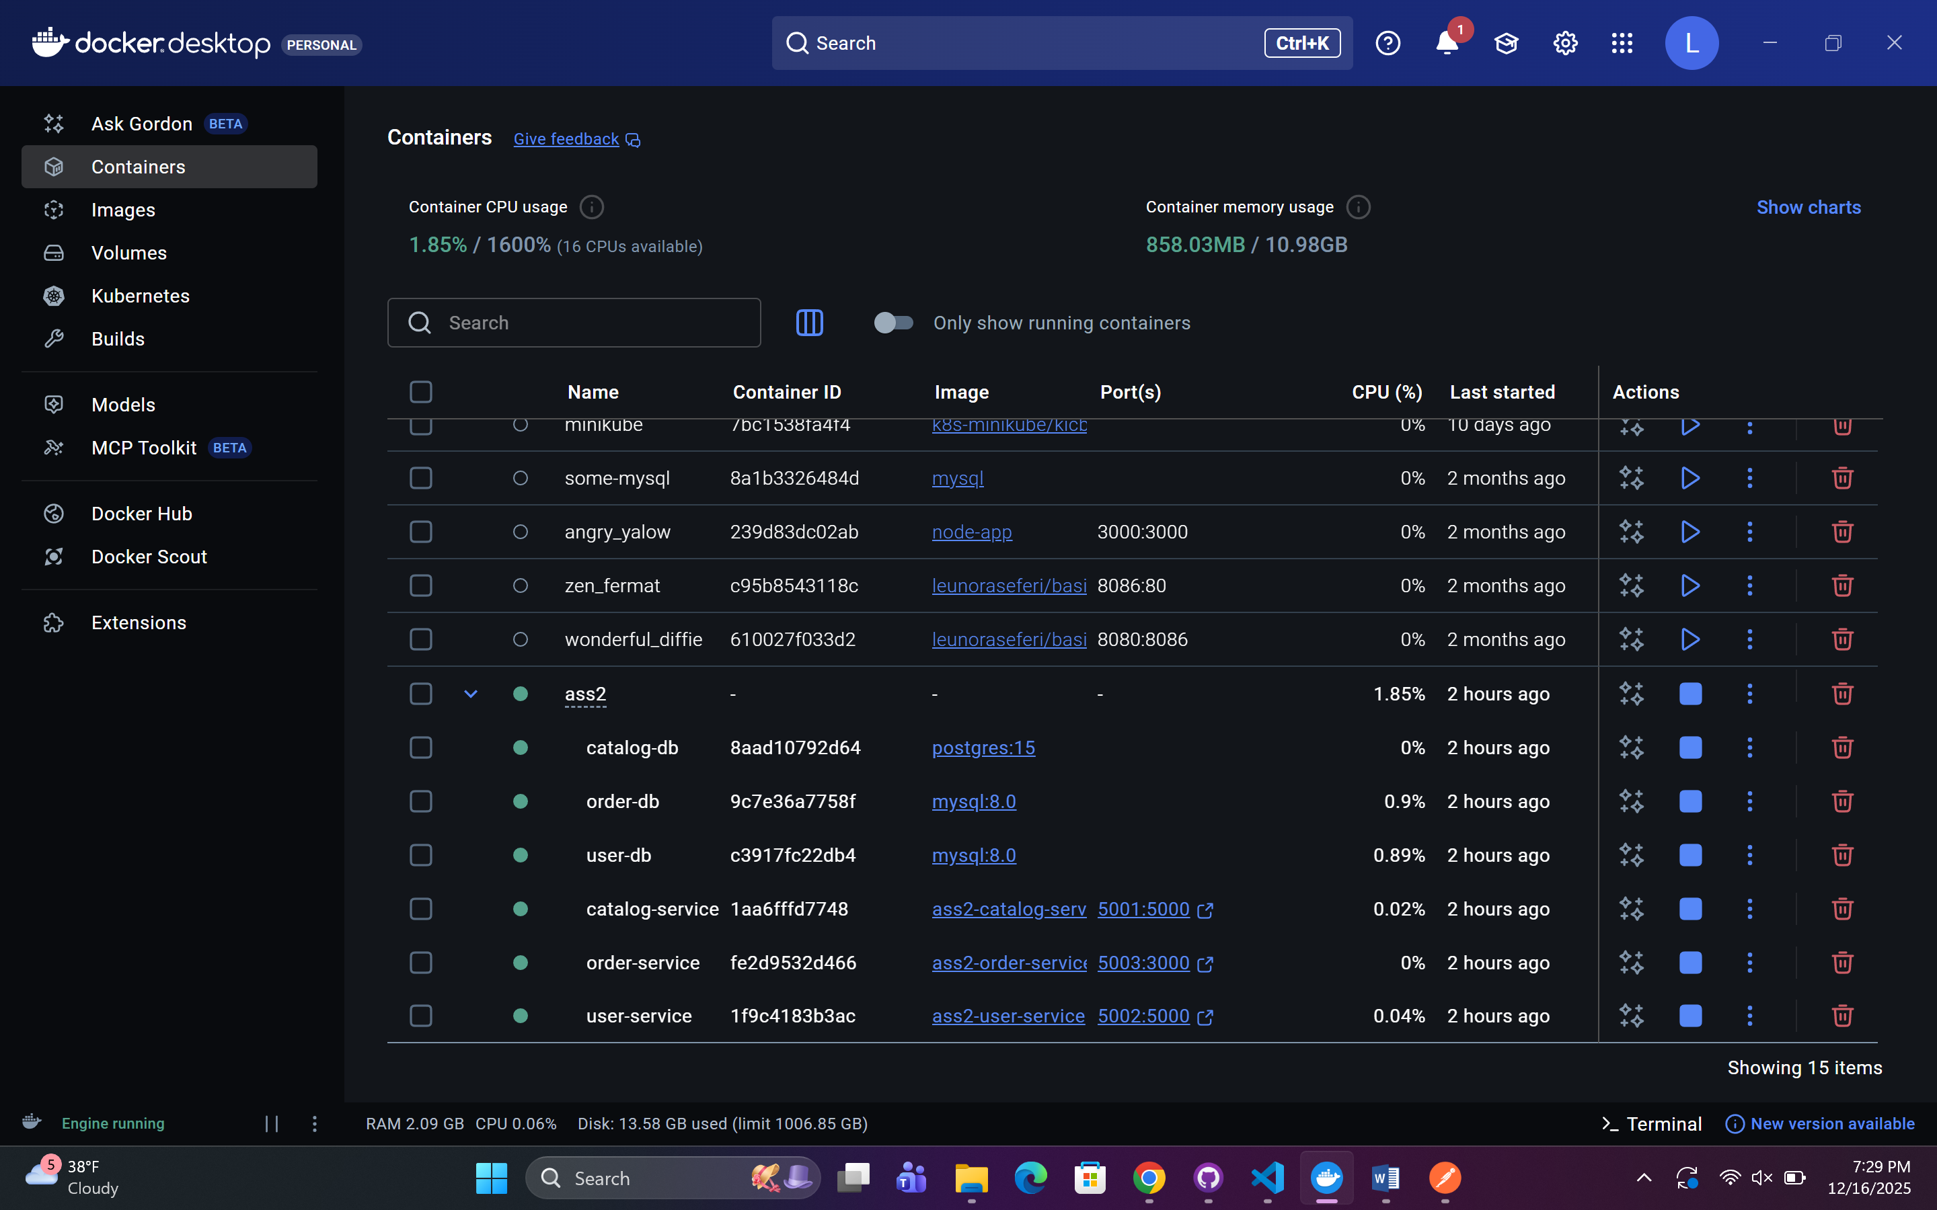

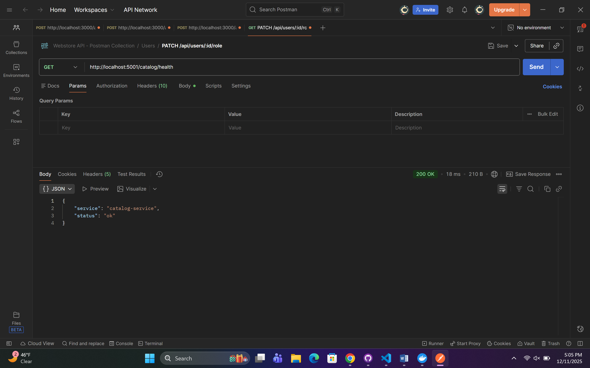

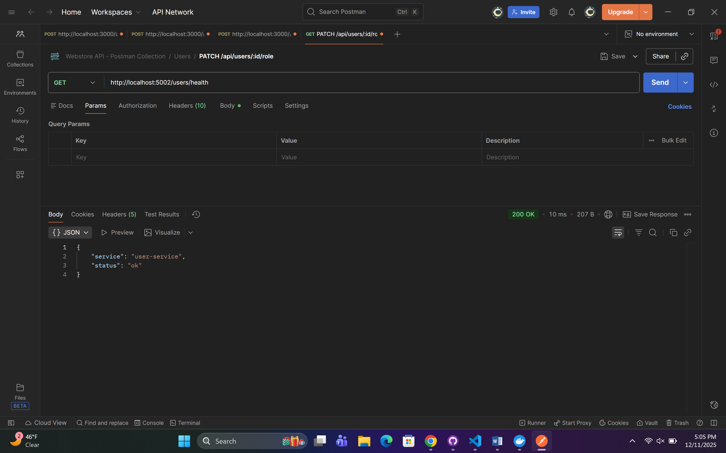

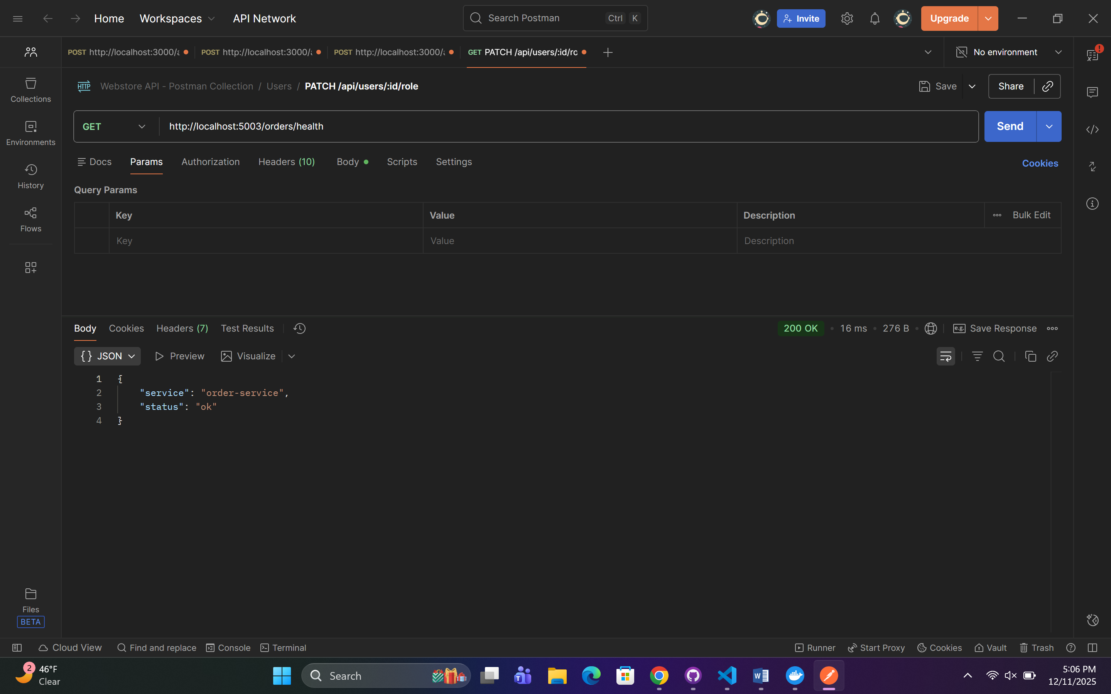

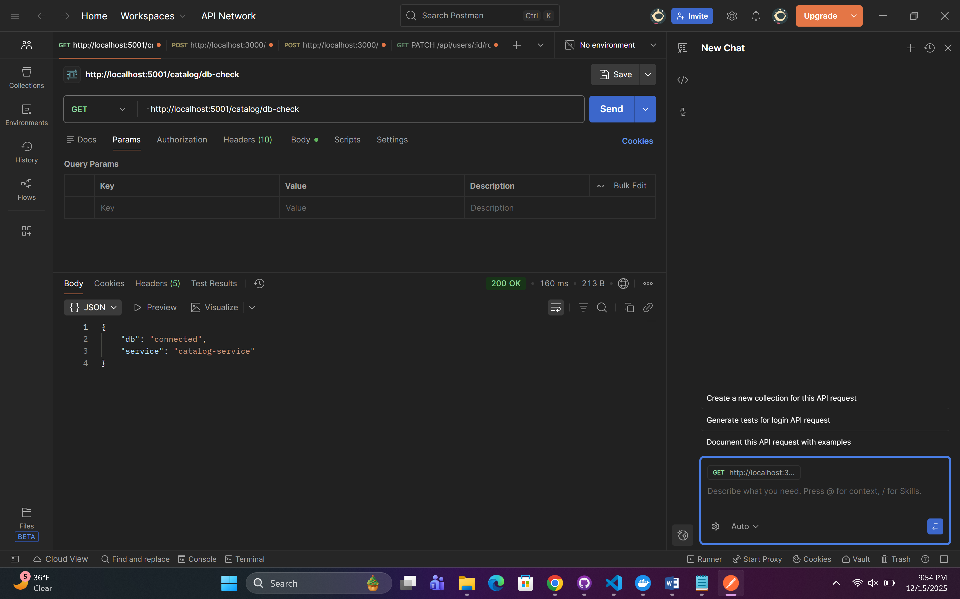

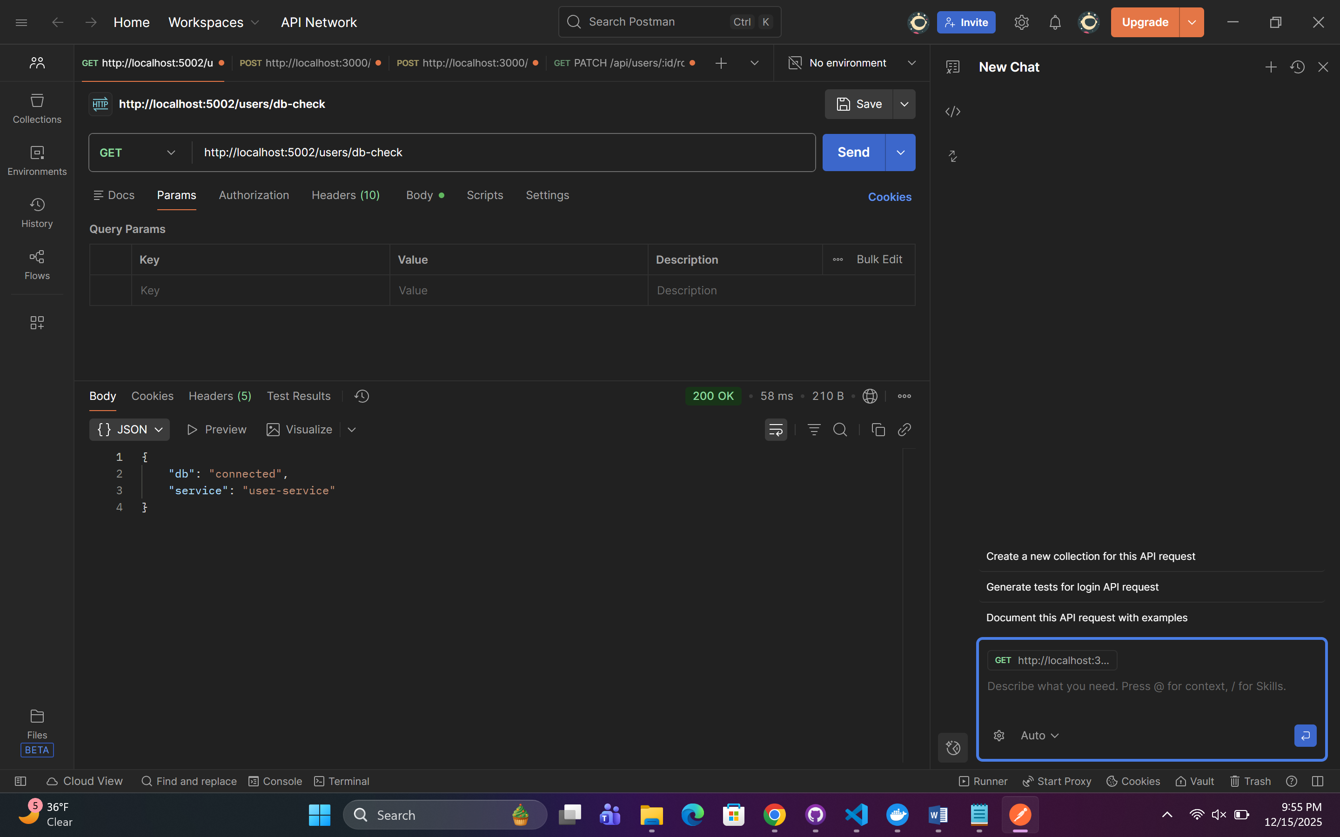

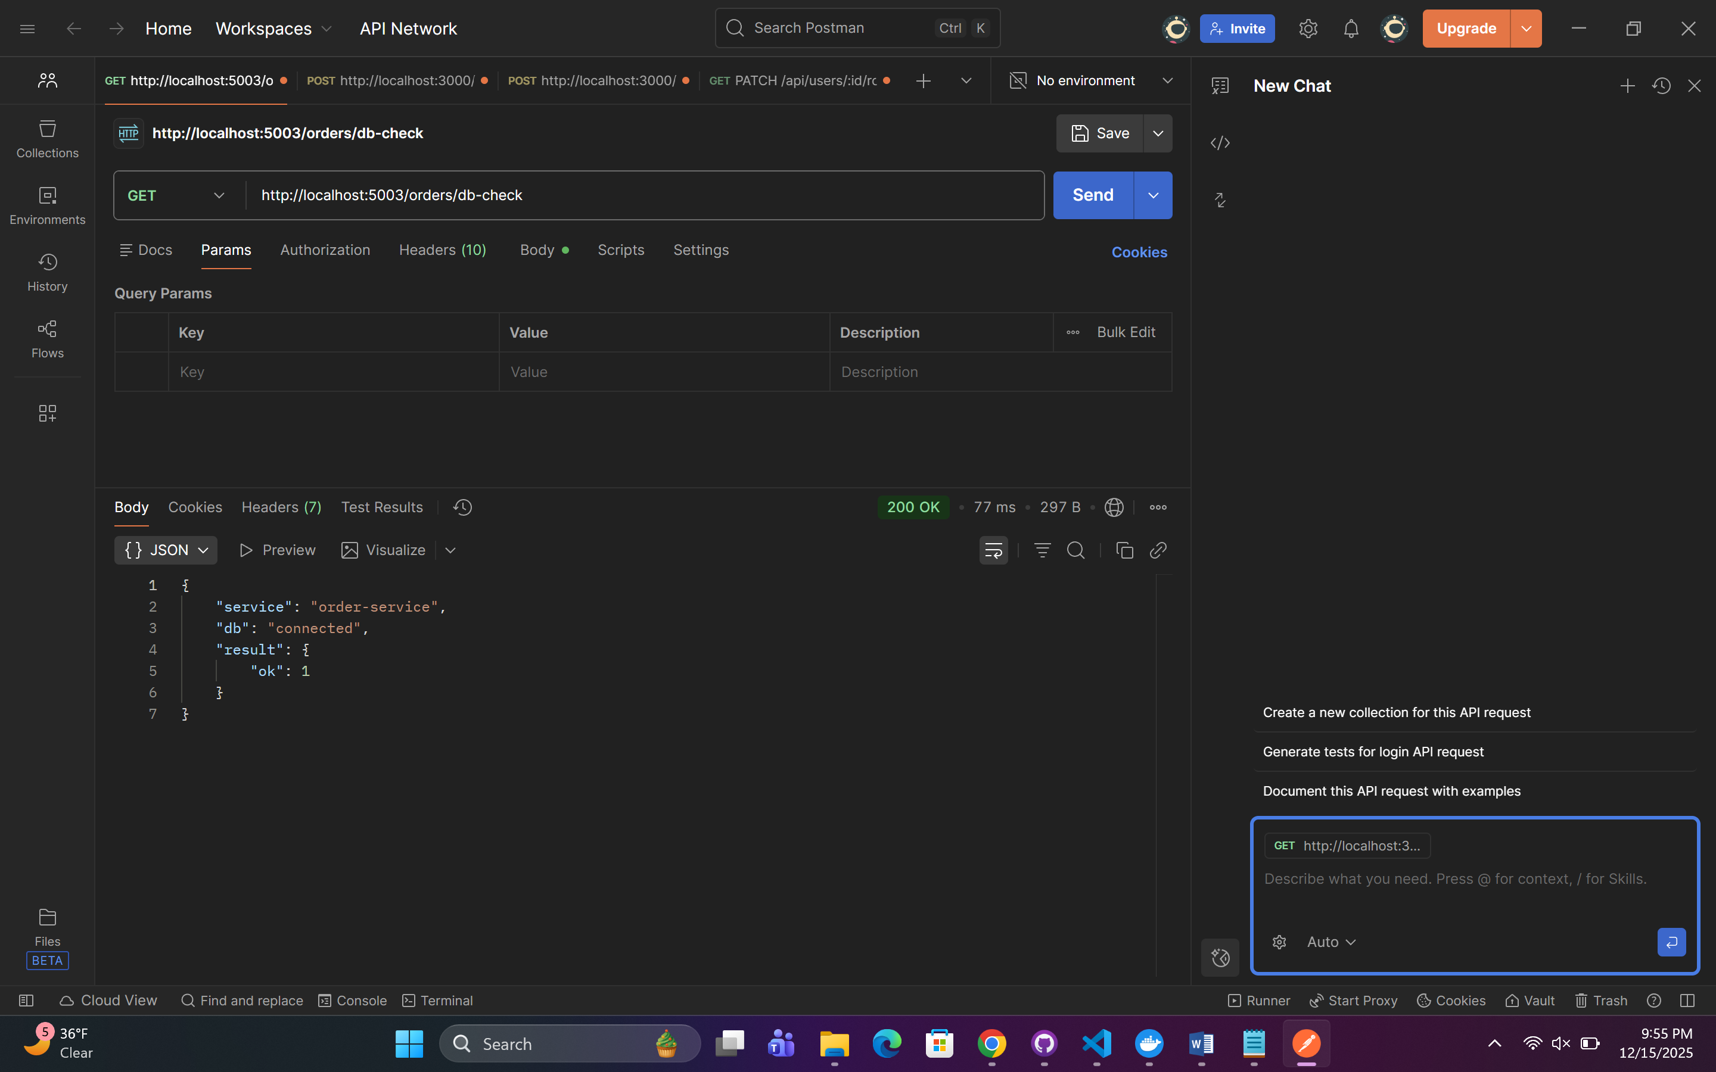

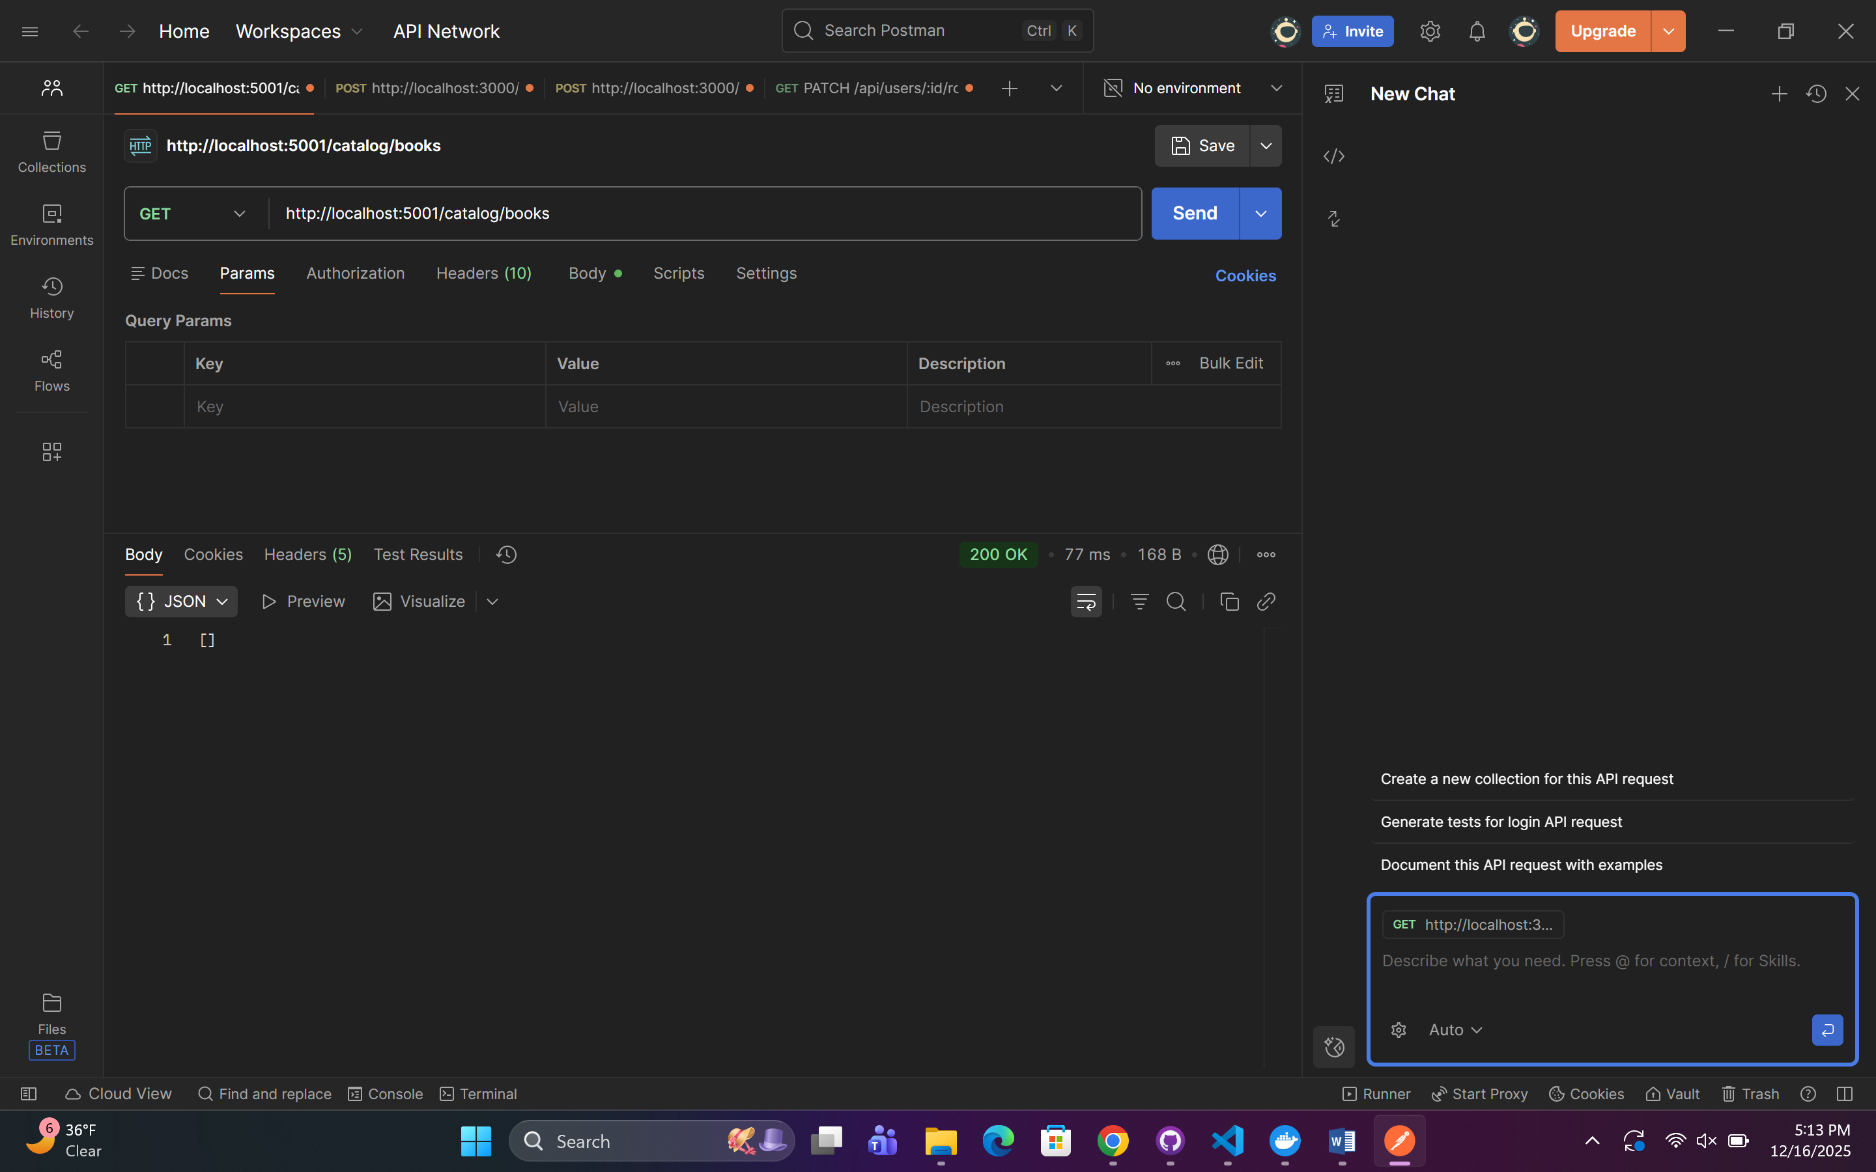

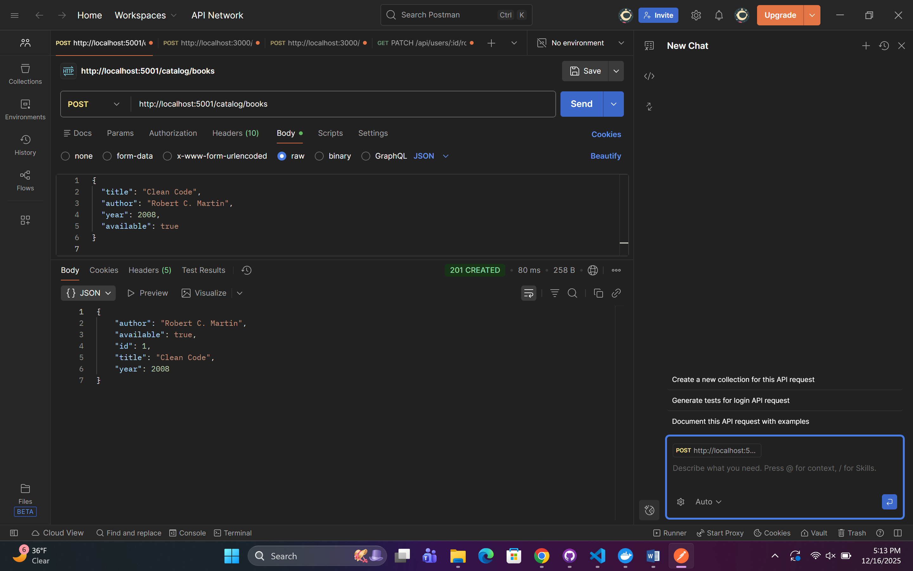

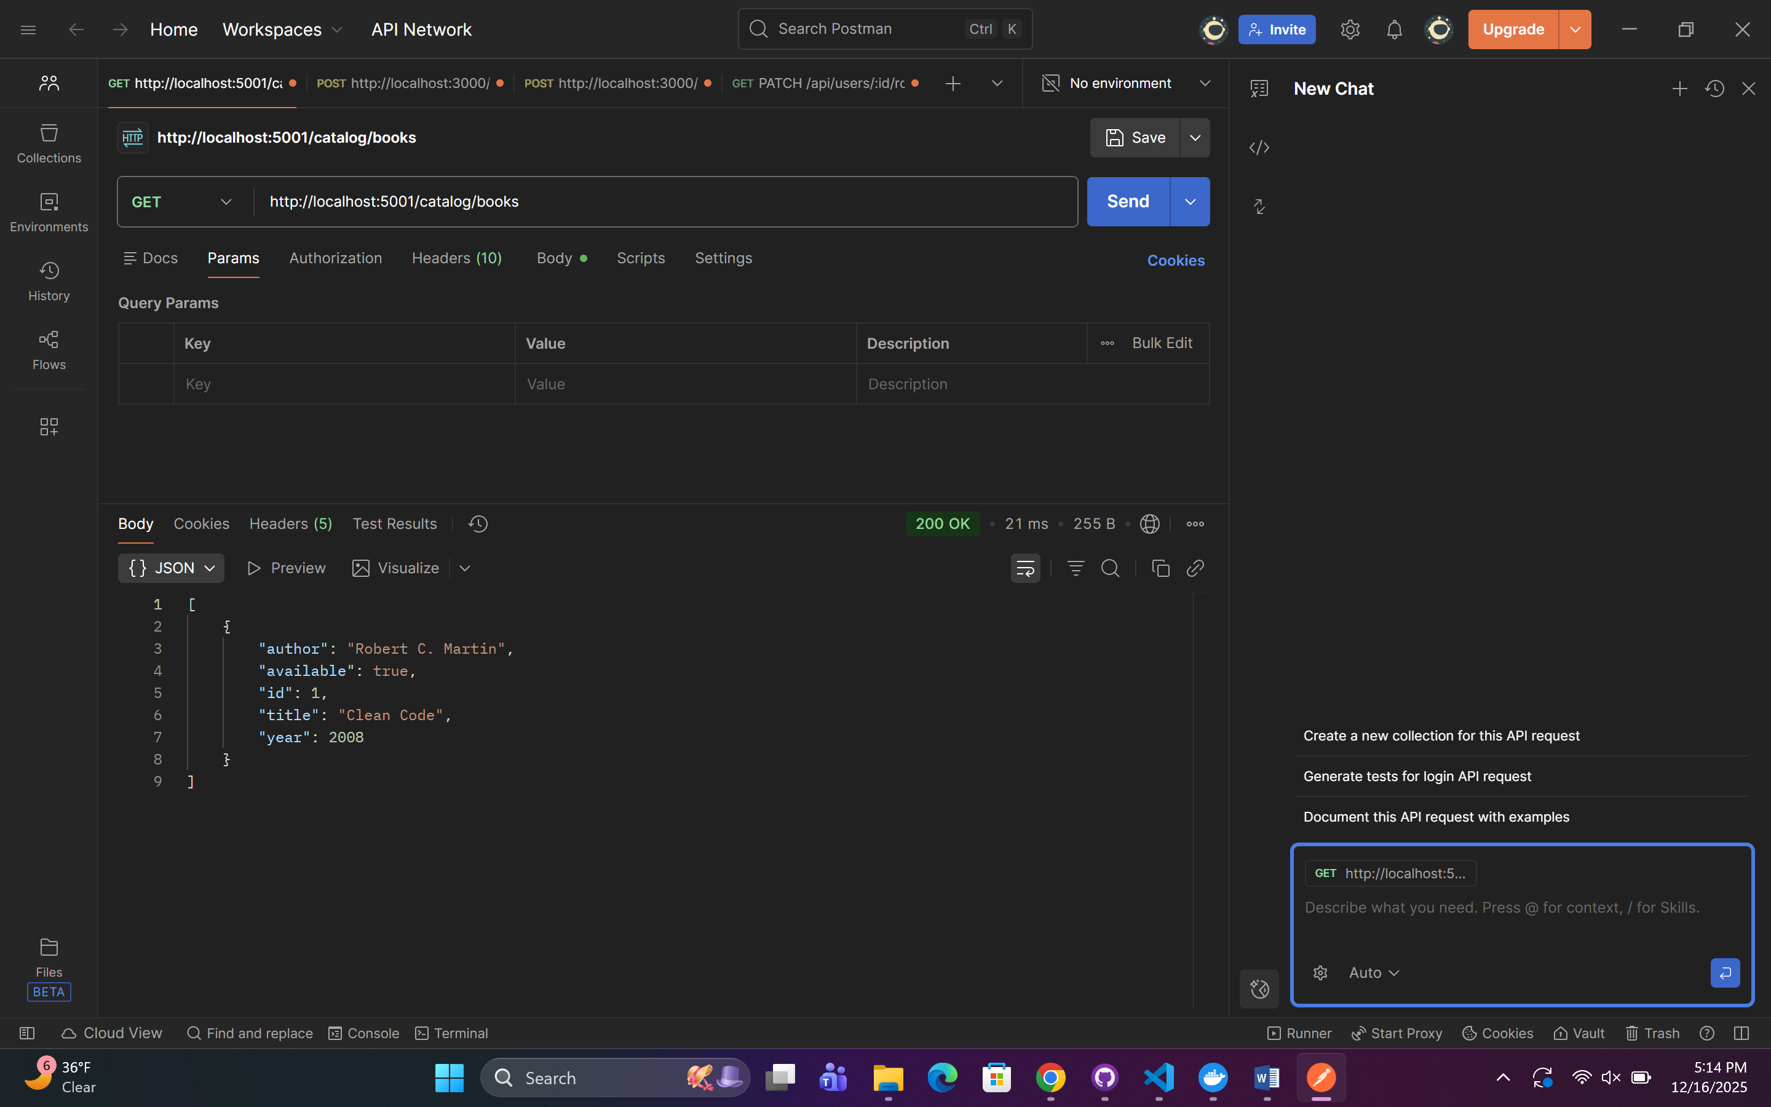

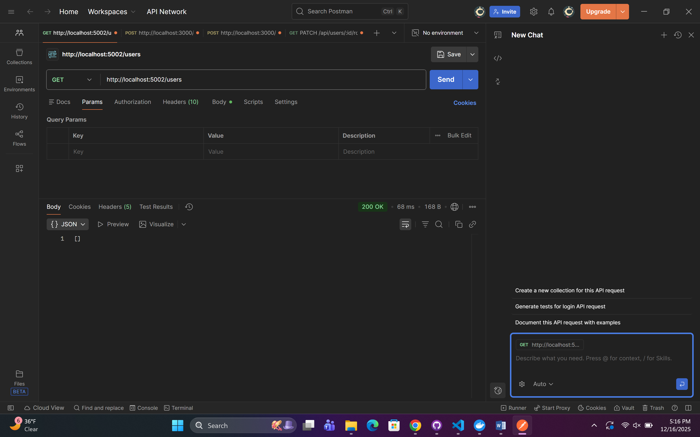

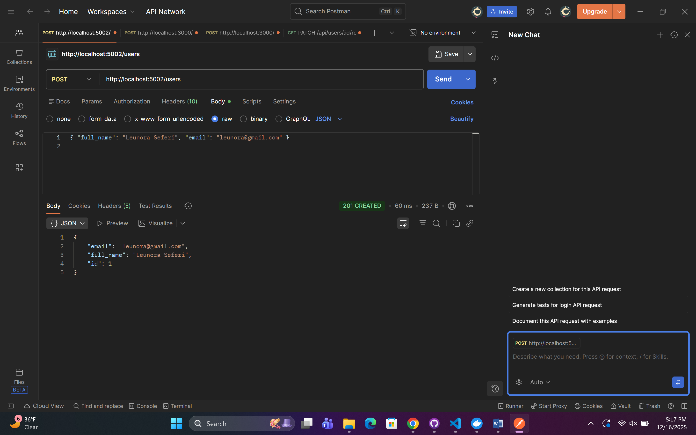

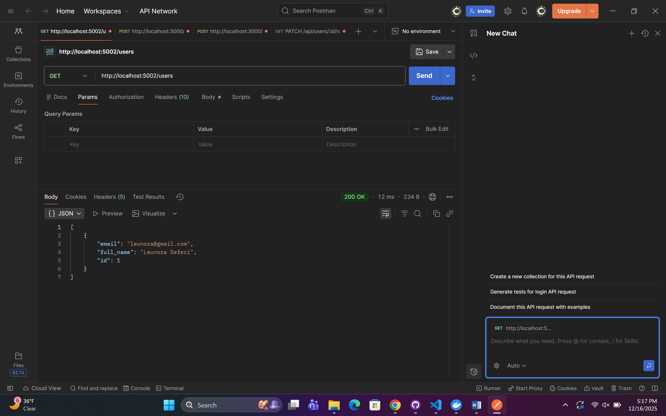

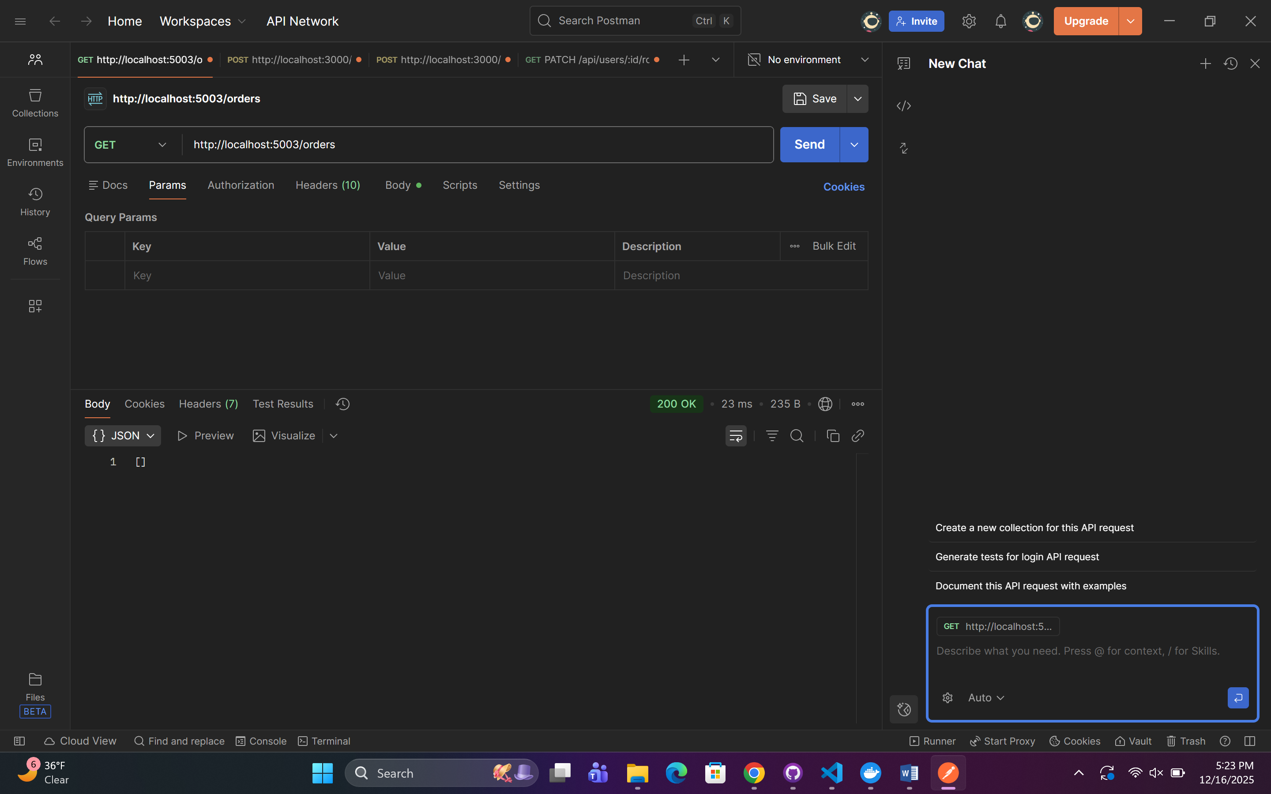

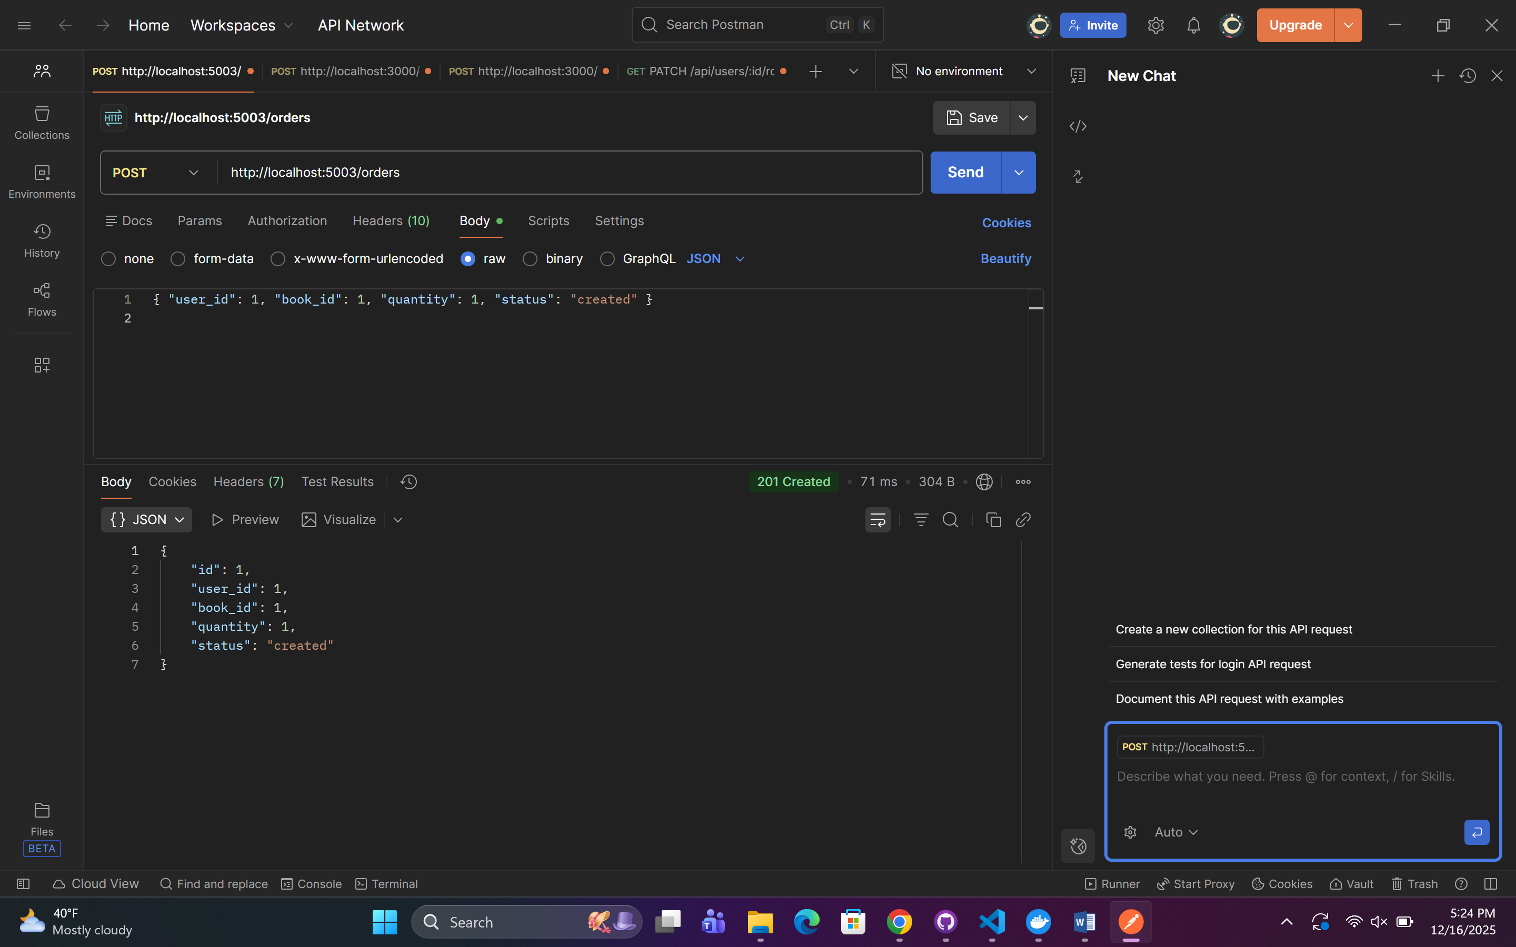

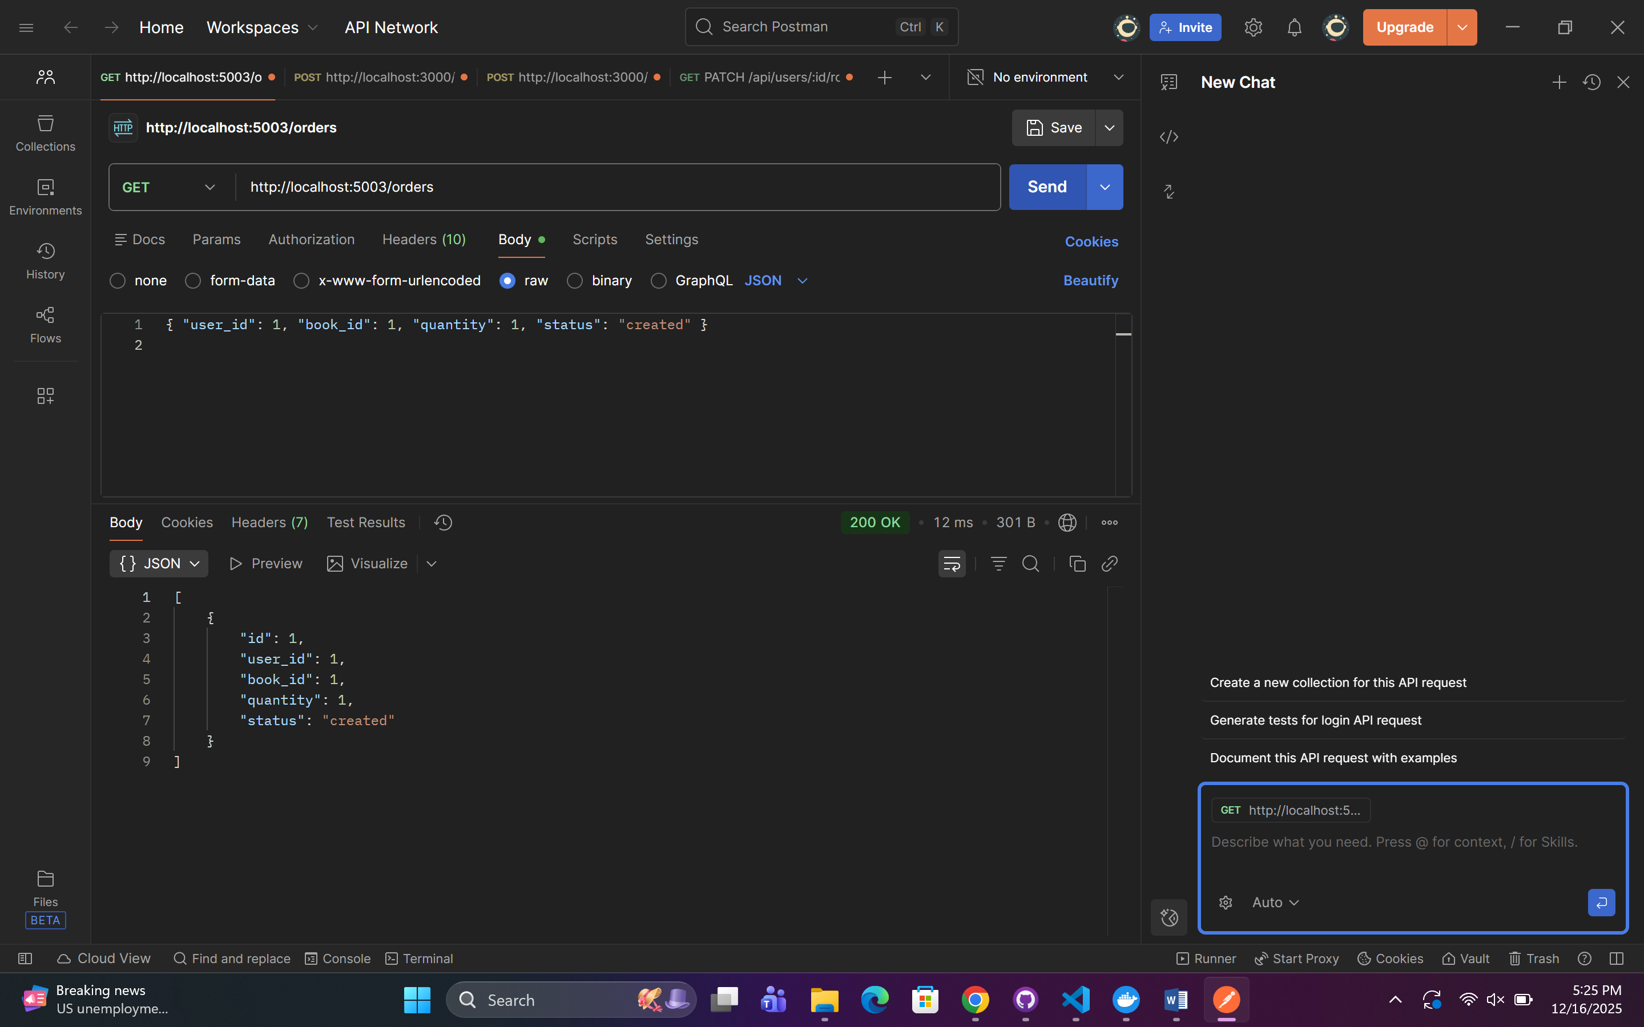

## Catalog Service — Books (Flask + PostgreSQL)

* CRUD operations for books

Implementation:

* **Create book** → POST /catalog/books
* **Read all books (MANDATORY)** → GET /catalog/books
* **Read single book** → GET /catalog/books/{id}
* **Update book** → PUT /catalog/books/{id}
* **Delete book** → DELETE /catalog/books/{id}

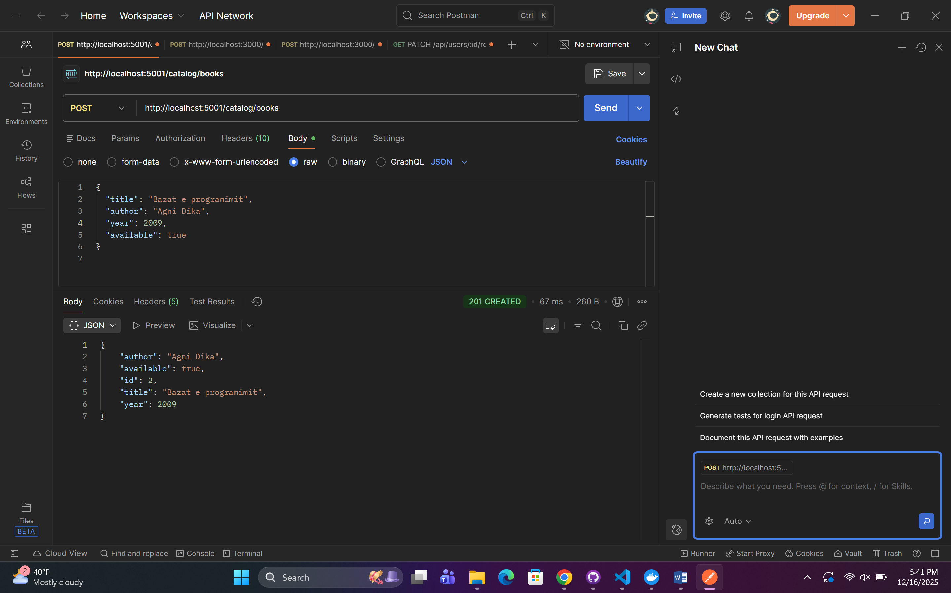

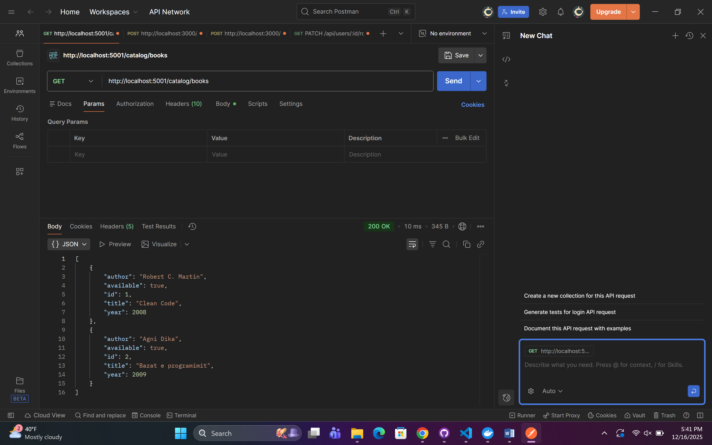

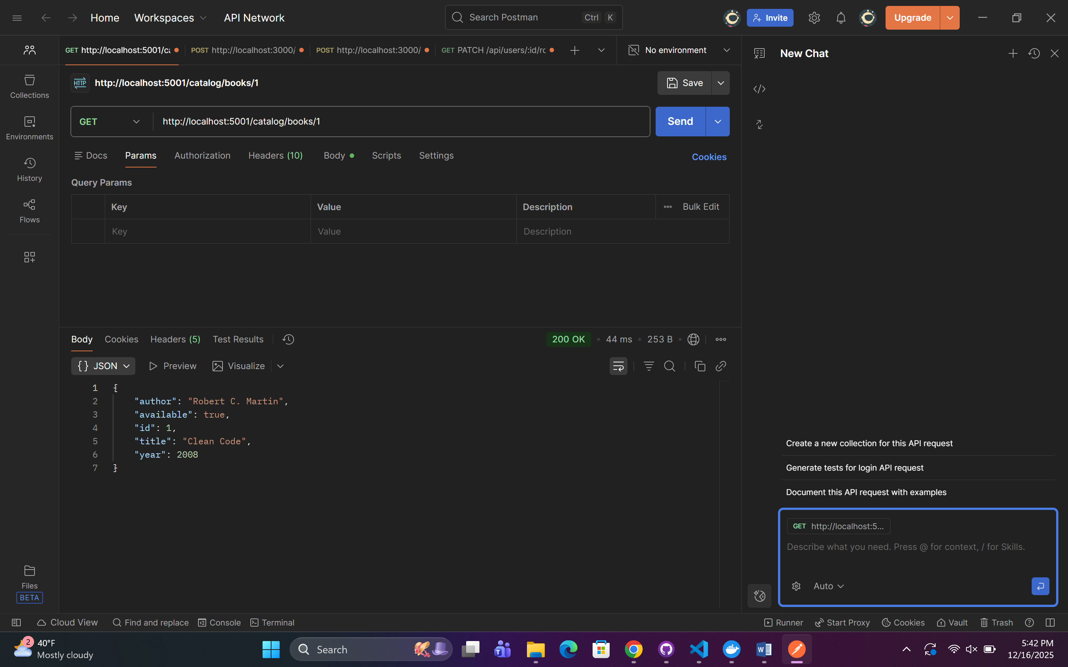**\**

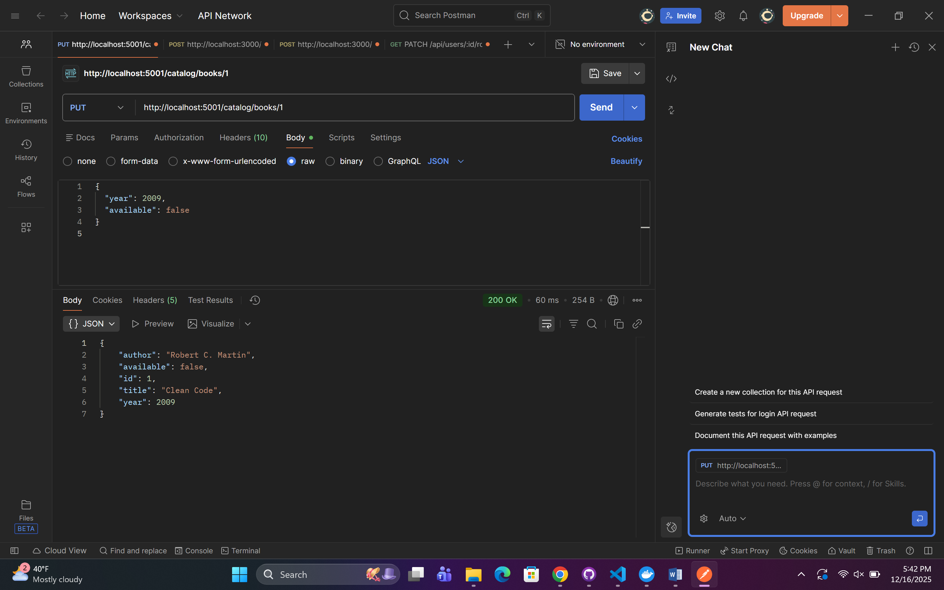

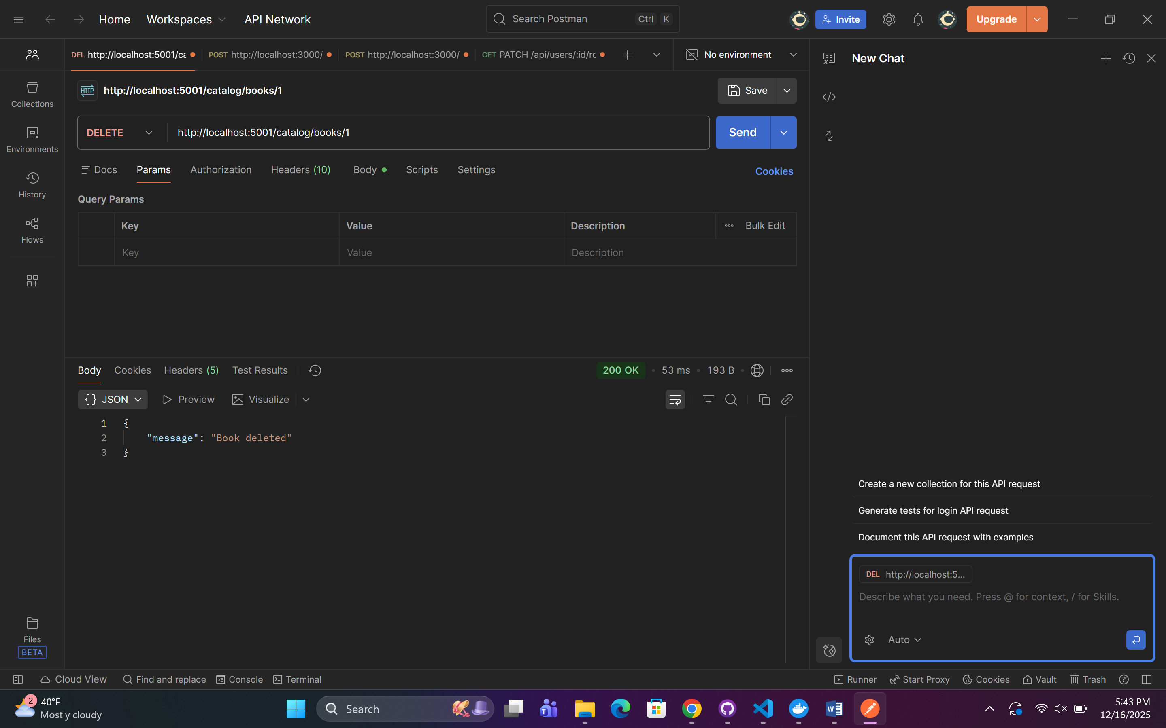

## User Service — Users (Flask + MySQL)

* CRUD operations for user profiles

Implementation:

* **Create user** → POST /users
* **Read all users (MANDATORY)** → GET /users
* **Read single user** → GET /users/{id}
* **Update user** → PUT /users/{id}
* **Delete user** → DELETE /users/{id}

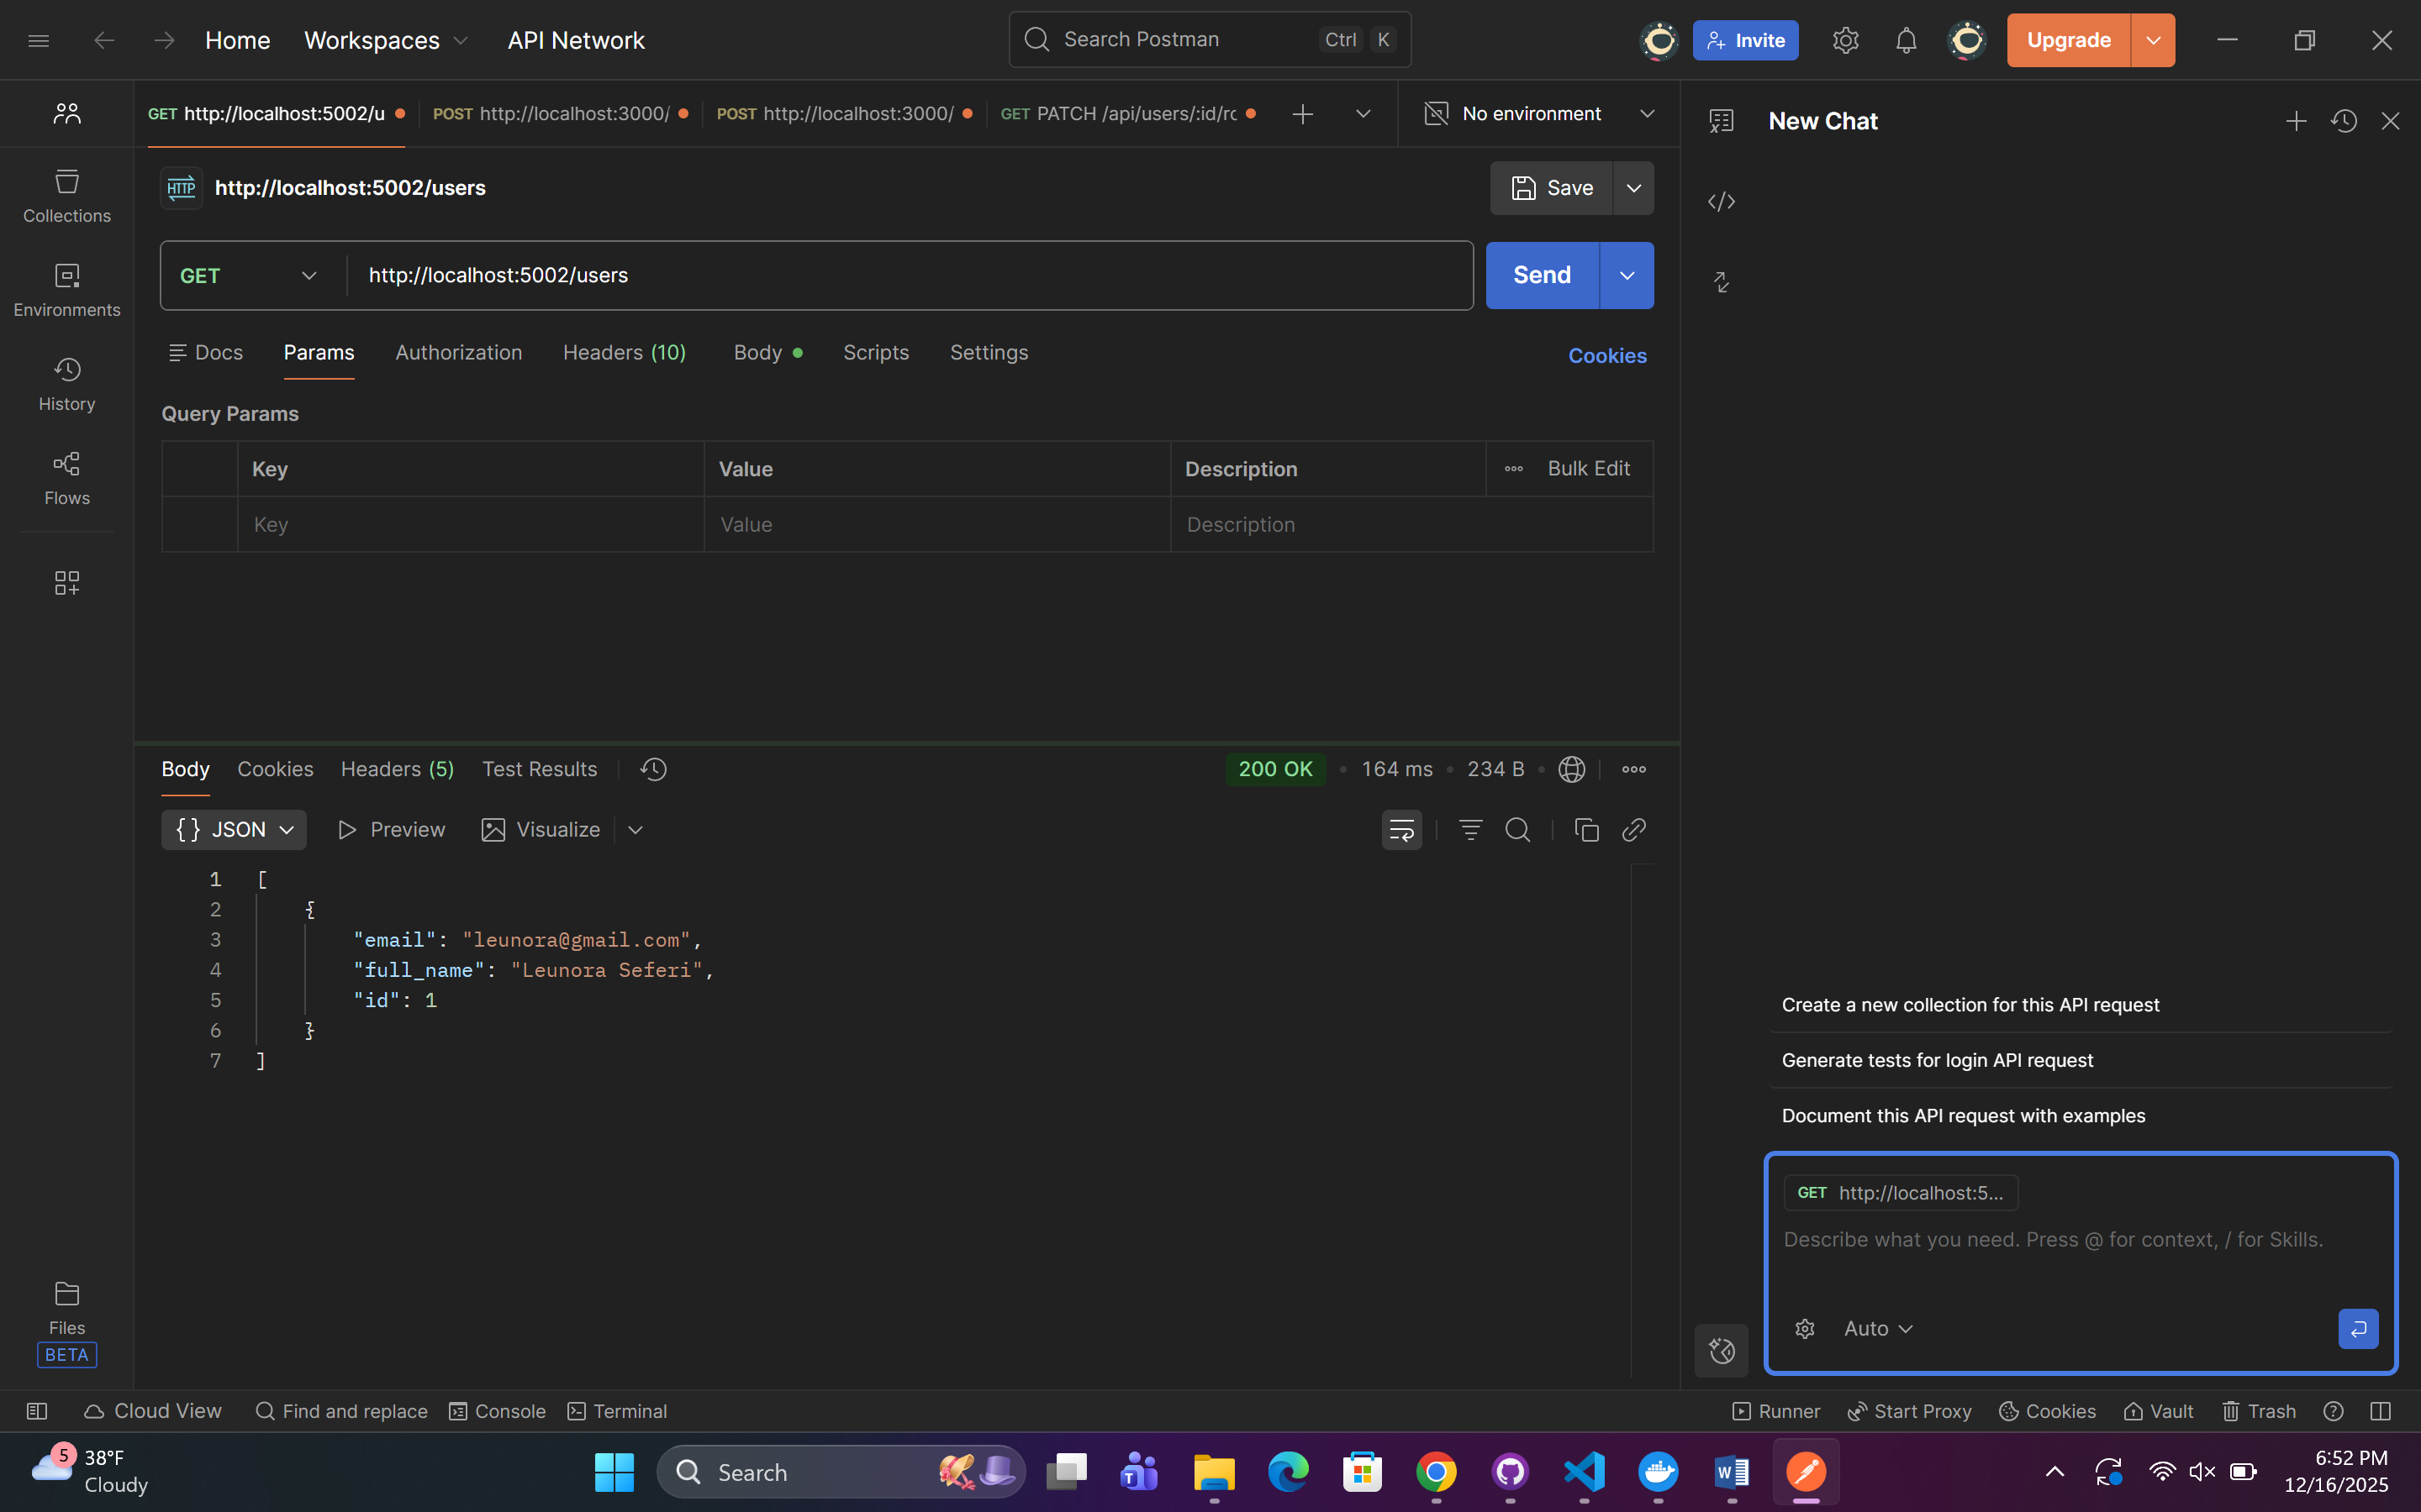

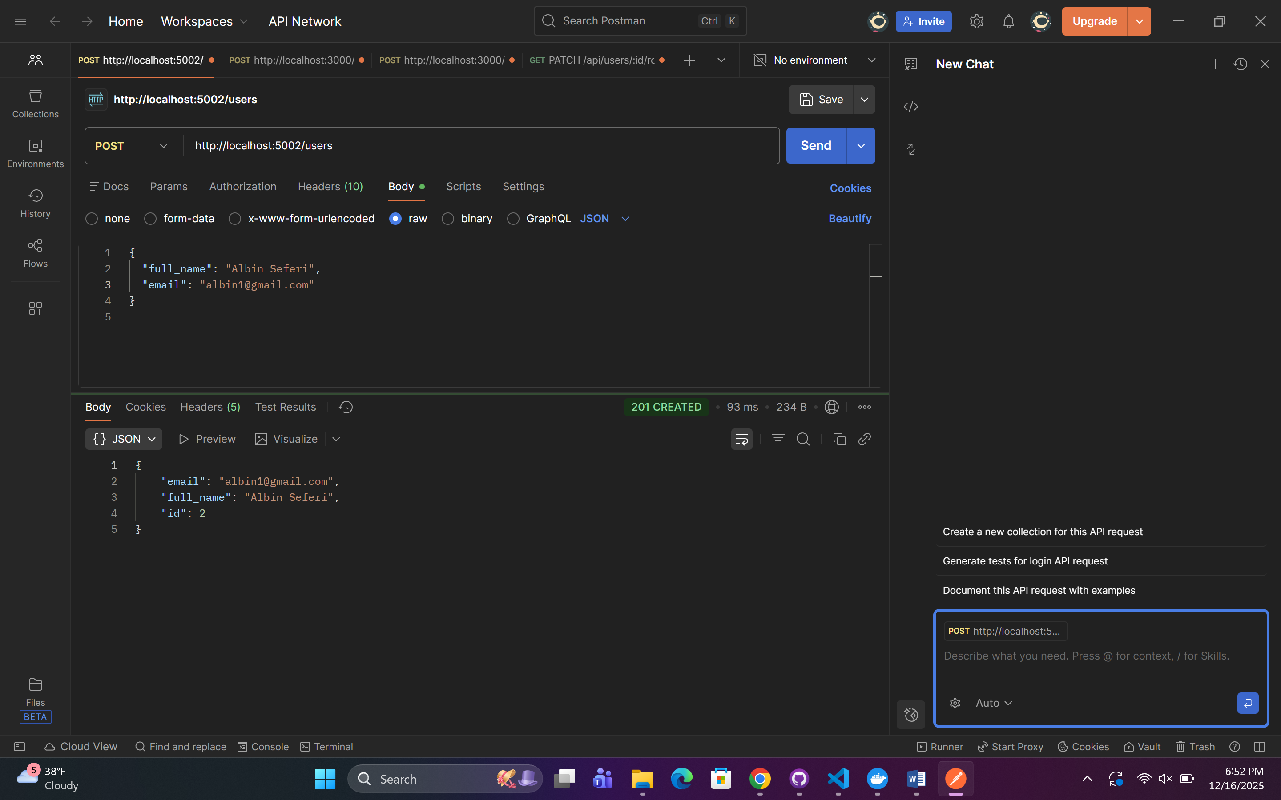

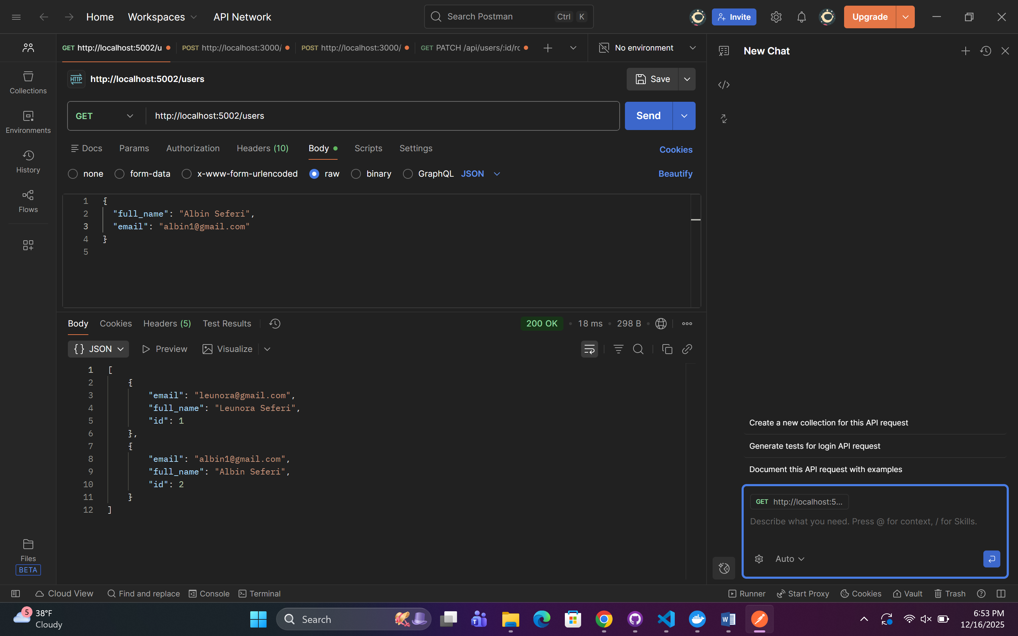

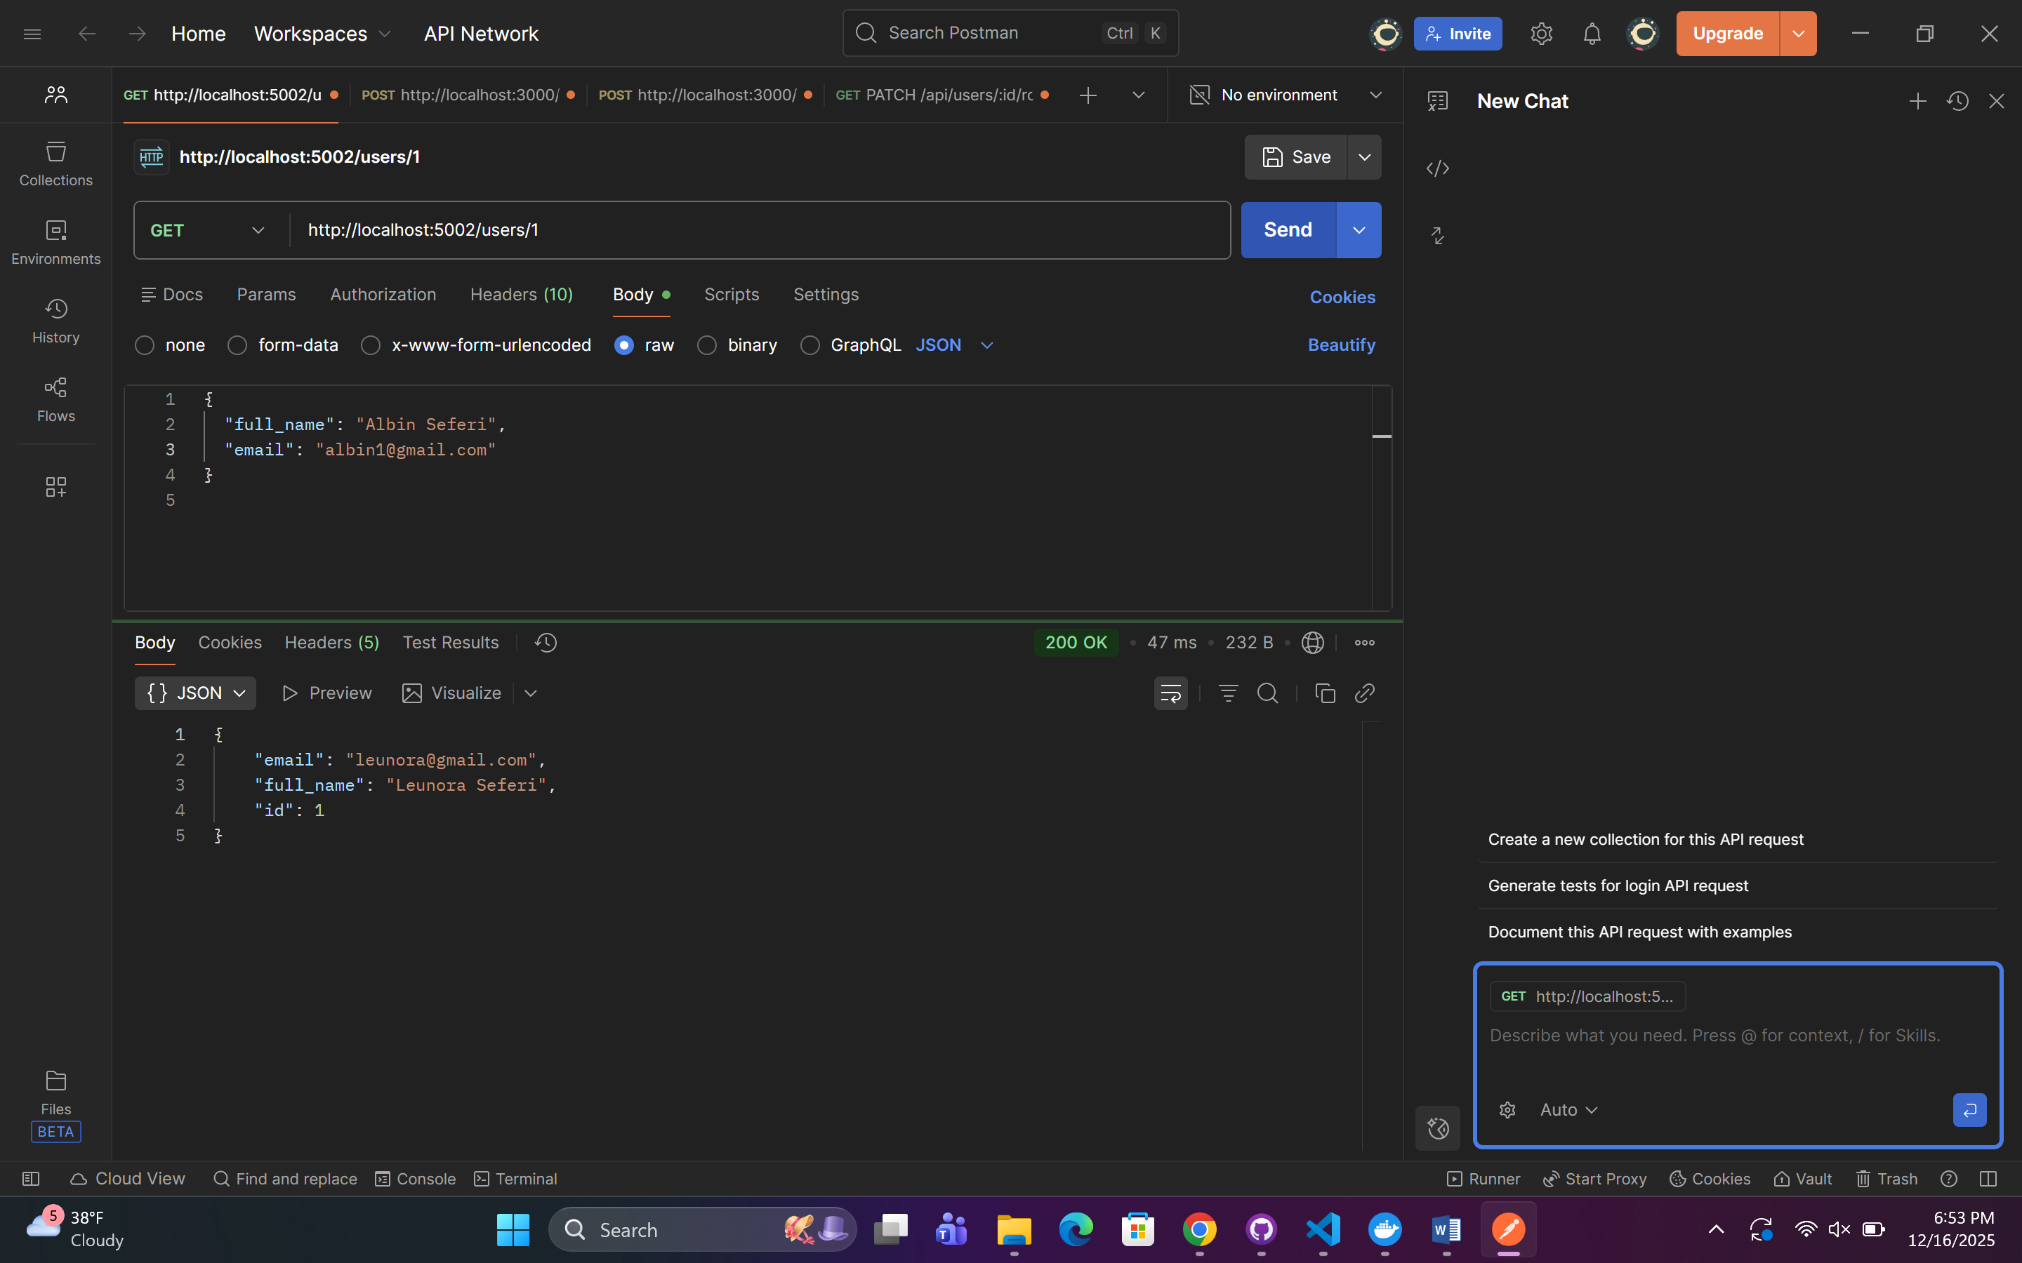

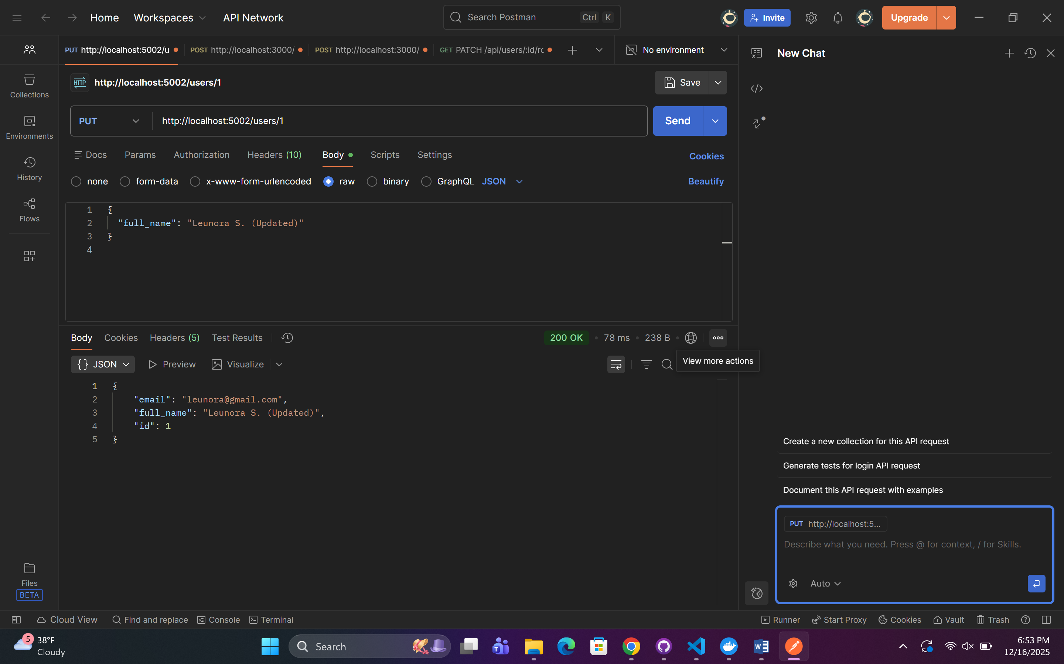

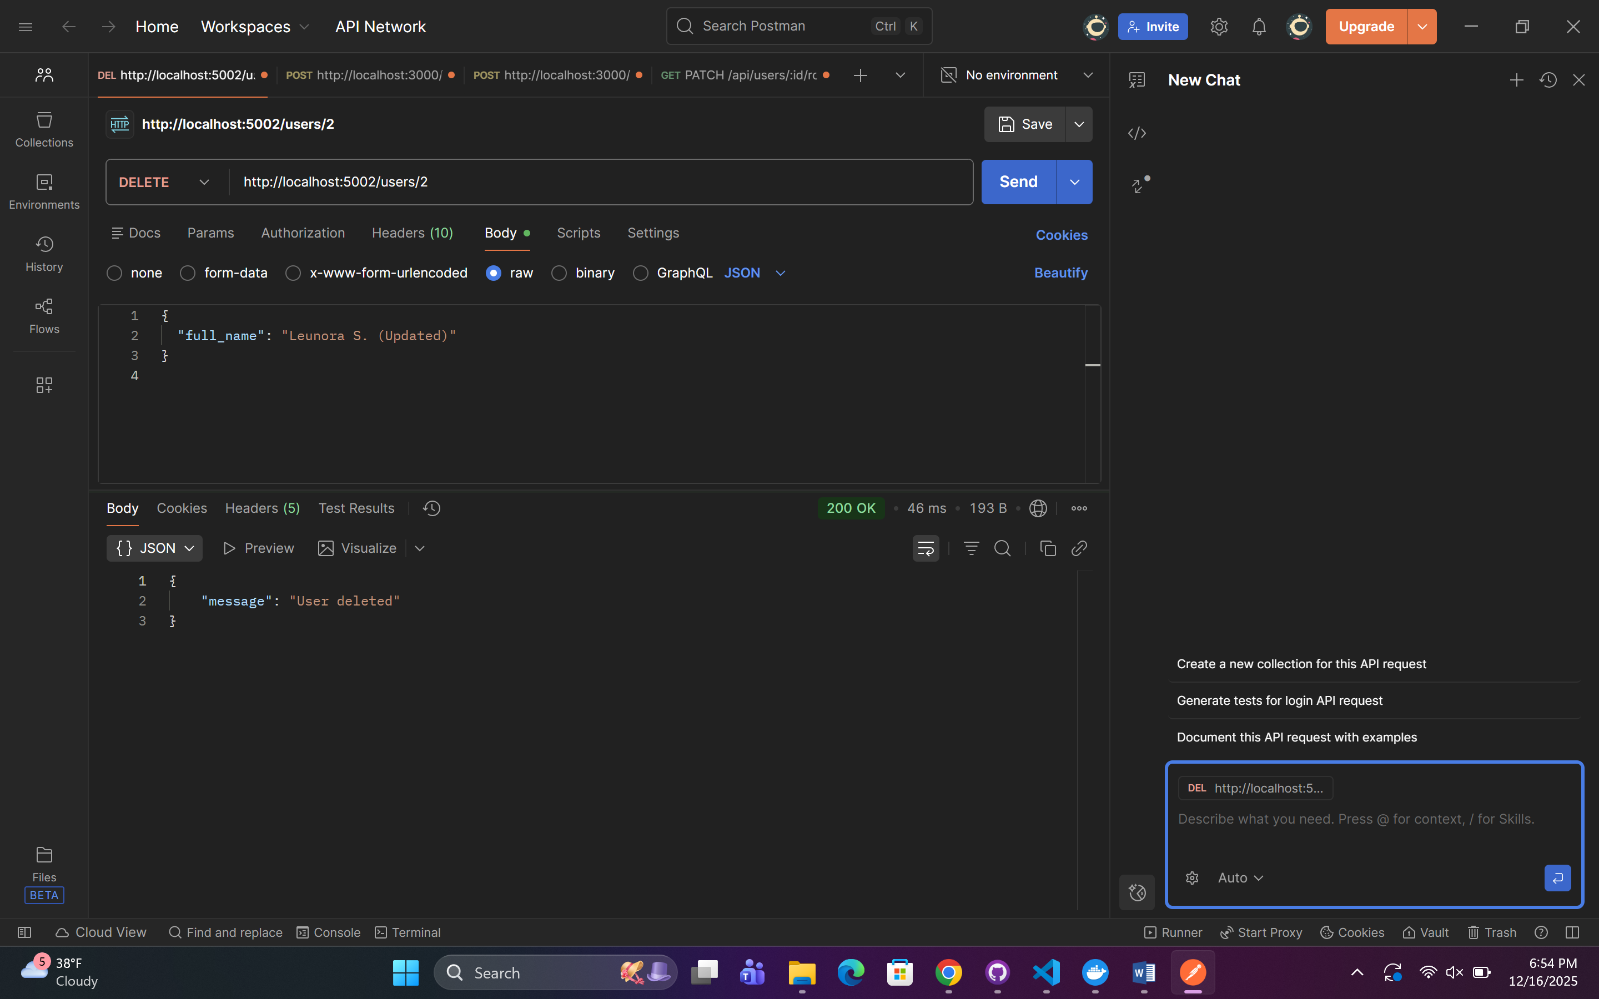

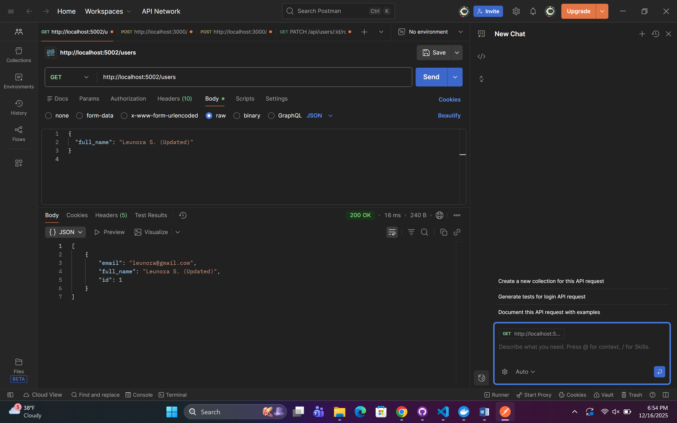

## Order Service — Orders (Node.js + Express + MySQL)

* CRUD operations for orders

Implementation:

* **Create order** → POST /orders
* **Read all orders (MANDATORY)** → GET /orders
* **Read single order** → GET /orders/{id}
* **Update order** → PUT /orders/{id}
* **Delete order** → DELETE /orders/{id}

